**Market Basket Analysis**

# INTRODUCTION

The retailer wants to target customers with suggestions on itemset that a customer is most likely to purchase .I was given dataset contains data of a retailer; the transaction data provides data around all the transactions that have happened over a period of time. Retailer will use result to grove in his industry and provide for customer suggestions on itemset, we be able increase customer engagement and improve customer experience and identify customer behavior. I will solve this problem with use Association Rules type of unsupervised learning technique that checks for the dependency of one data item on another data item.

In this phase the design to innovation and data flow of market business analysis is going to be done.

# DATASET

The data is obtained from <https://www.kaggle.com/datasets/aslanahmedov/market-basket-analysis>

# COLUMNS USED

##### From  Assignment-1_Data data the following columns are used

* Bill no
* Item name
* Quantity
* Date
* Price
* Customer id
* Country

# LIBRARIES USED

* Arules
* arulesViz
* tidyverse
* readxl
* ggplot2

### Data Pre-processing

Next, we need to upload Assignment-1_Data. xlsx to R to read the dataset.Now we can see our data in R.

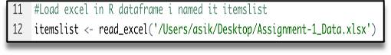

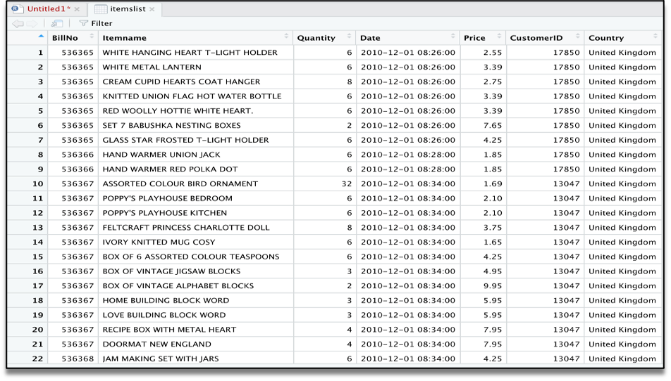

The summary gives us some useful information:

* Density tells the percentage of non-zero cells in a sparse matrix. In other words, total number of items that are purchased divided by a possible number of items in that matrix. You can calculate how many items were purchased by using density: 18193x7698x0.002291294=337445
* Summary will show us most frequent items.
* Element (itemset/transaction) length distribution: It will gave us how many transactions are there for 1-itemset, 2-itemset and so on. The first row is telling you a number of items and the second row is telling you the number of transactions.  
  For example, there is only 1546 transaction for one item, 860 transactions for 2 items, and there are 419 items in one transaction which is the longest.

# image

### Visualizing Association Rules

We have thousands of rules generated based on data, we will need a couple of ways to present our findings. We will use ItemFrequencyPlot to visualize association rules.

#### Scatter-Plot:

# image

# image

# image

Market Basket Insights

